Problems of Phase Plane Analysis

PP-1. Draw a phase-plane portrait of the following system:
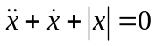
PP-2. Consider the system shown in Fig. PP-1. Draw phase-plane portrait for it in the 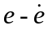 plane when K = 0 and K = 1. Assume that the input 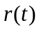 is zero for t > 0, and the system is subjected only to the initial condition.
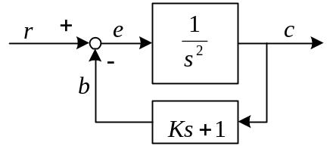 Fig. PP-1
PP-3. Figure PP-2 shows a second-order system with a nonlinear feedback gain. The block K indicates a proportional control gain, and the block 1/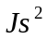 indicates a pure inertia load. The characteristic of the nonlinear element in the tachometric feedback loop is that of saturation.
Plot typical trajectories in the plane, showing the responses to various initial conditions. Assume that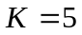, 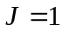, and 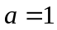.
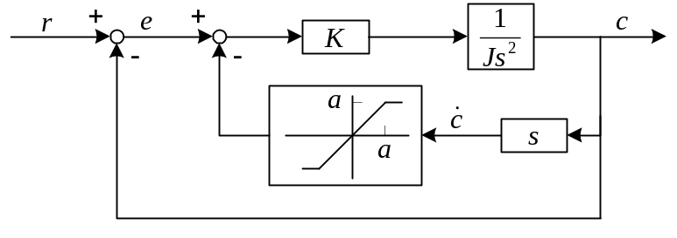 Fig. PP-2

